**MINI PROJECT REPORT**

**ON**

**“Detective Agency”**

**Submitted in partial fulfillment of the requirements for the degree of**

**Master of Computer Applications (MCA)**

**SUBMITTED BY:**

**DEEPAK SINGH**

**ENROLLMENT NO.:** PV-23010274

**CLASS ROLL NO.:** 53(C)

**EMAIL:** [priyanshudhyani34@gmail.com](mailto:priyanshudhyani34@gmail.com)

**PHONE NO.:** +91 **(**9808) 129-751

**UNDER THE GUIDANCE OF**

DR. POONAM VERMA

DEPARTMENT OF SCHOOL OF COMPUTING

**NOVEMBER, 2024**



**Department of Computer Applications**

**Graphic Era Hill University**

**Bell Road, Dehradun**

**ACKNOWLEDGEMENT**

The satisfaction that comes with successfully completing any task would be incomplete without acknowledging the individuals whose unwavering support and guidance made it possible. We express our heartfelt gratitude to our project guide, Prof. Poonam Verma, for their constant encouragement, inspiration, and invaluable support throughout the design and implementation of this project.

We deeply appreciate their constructive feedback and insightful suggestions, which significantly contributed to the project's success.

We also extend our sincere thanks to our colleagues for their assistance and cooperation in ensuring the successful completion of this project.

**Priyanshu Dhyani**

**ABSTRACT**

This project is a combination of all the process performed by an organization. Through this project we can easily delete, update, and insert the records. It will also provide the facility of adding more HR Data from anywhere if required. All forms are connected with each other so that we can easily understand the working of project. In this project we easily insert the HR Data through form provided to the admin for updating the jobs which is required.

Database is playing an important role for keeping the record of User Data , Employee data , Test Questions, Login Detail, Registration in a synchronized manner. This project will be efficiently suitable for learning about the working of each PHP, Javascript, HTML, and My-SQL command used for accessing the actions required in this project.

**CONTENTS**

* Introduction to Project 8-9
* Objectives 10-11
* Identification of need 12-16
* Feasibility Study 17-20
* Software And Hardware Requirement Specifications 21
* Performance Factors 22-23
* Pert Chart 24-25
* Gantt Chart 26-27
* Data Tables 28-31
* Flow Chart 32-33
* Entity Relationship 34-36
* DFD 37-38
* Coding 39-95
* Screenshot 96-104
* Testing Objective 105-109
* Conclusion 110
* References 111

**Introduction**

For all types of law agencies need to manage their records in such a way that they can retrieve the information as per requirement. They need a set of rulebooks, such as Detail of clients, Staff, cases, and lawyers etc. Unless the transactions are recorded properly, Accountant will not be in a position to know where exactly he stands. Therefore, any business record keeping is of foremost importance.

Handling the Law Agency manually is quite difficult so this website provides aid to the manage by providing easy access to the records. This will improve the efficiency of the work because manually it would take a long time to search for and keep track of all the records of the transactions taking place in the company.

Following is the complete ***cycle of Agency***:

1. The Detail of clients, lawyer/cases and other details are first recorded in a file.
2. Periodically these information are transferred to concerned Database.
3. At the end of every information report can be seen.

### An additional feature of the website is that it provides security to the Management. It is Password-Protected software, which provides for two types of logins, which are User login and Administrator login.

Another salient feature is the Reports Generation facility, which includes the reports for daily transactions and monthly reports. Above - mentioned are some of the prime features of the website developed. It also covers all the basic tasks covered by Information.

## **OBJECTIVE**

The main objective of the project is to computerize all the aspects related to Law Agency.

Every business in today world requires proper Information. Using manual approach, maintaining a large number of books is time consuming and error prone.

Time consuming, because a number of books are to be maintained for the same transaction and error prone, because posting of same transactions over number of books may result in human caused errors .

The main aim is to develop software to get fast access of information / reports at user’s choice; also to completely eliminate the errors occurred during posting of information.

In brief, the following points describes the main objectives to be achieved through this website:

* To fully ***computerize*** all the aspects of information system.
* To design a system that gives the ***faster*** results and is ***more efficient***
* To provide a ***user-friendly*** system that is easier to access
* To make the package easy to access by providing ***Menu-Driven*** options
* To design a system that is ***reliable***
* To limit human caused errors while posting the transactions into various books.
* System could add new records maintain them in database.
* To develop ***highly secure*** software system to avoid any unauthorized user to access any kind of information by providing some security features like:

***Administrator: -*** Administrator has his own user name and password to access the package. The Administrator has privileges to update, delete and create user. Administrators can also rollback the database, if required.

***User: -*** User has his own user name and password. User has all the privileges except deletion, updation and creation of the user. User cannot rollback the database without the permission of administrator.

* To maintain integrity and prevents the unauthorized access.
* To provide better information facilities.

**IDENTIFICATION OF NEED**

**Manual systems often lead to several challenges, including:**

1. **Reliability:** Manual processes depend on human factors, making them less reliable. Computer systems, on the other hand, offer proven reliability over time.
2. **Accuracy:** Manual systems are prone to errors, especially with complex or high-volume transactions. Computerized systems are more accurate if properly programmed.
3. **Economy:** Manual processes require significant manpower, increasing costs. Automation reduces these expenses.
4. **Timeliness:** Manual systems delay information retrieval, whereas computerized systems ensure instant access.
5. **Paperwork:** Manual systems require extensive file management, which is prone to damage. Computers provide organized, long-term storage with backups.
6. **Redundancy:** Manual systems often duplicate data. Automation eliminates this issue.

**System Requirements**

1. **Correctness**: Software must meet functional specifications accurately.
2. **Robustness**: It should handle unexpected scenarios effectively
3. **User-Friendliness:** The system must be intuitive and easy to use.
4. **Verifiability:** Properties should be easily testable.
5. **Maintainability:** Easy to modify post-release.
6. **Reusabilit**y: Components should be adaptable for other applications.
7. **Portability:** The system should work across various hardware and software environments.

**FEASIBILITY STUDY**

**1. Technical Feasibility:**

Assesses whether the required technology exists to meet user requirements, including output production, response time, transaction processing, and data communication.

**Key considerations:**

* Necessary technology exists.
* Proposed equipment can handle data and is upgradeable.
* Ensures accuracy, reliability, usability, and data security.

**2. Operational Feasibility:**

Examines human and organizational factors, such as:

* Changes introduced by the system.
* Impact on organizational structures.
* Skills required and training needs.

**3. Economic Feasibility:**

Uses cost-benefit analysis to weigh project costs against tangible and intangible benefits. This ensures economic justification for the proposed system.

**4. Social Feasibility:**

Evaluates whether the project will be accepted by the affected users. This system is deemed socially feasible.

**5. Management Feasibility:**

Determines if the project is acceptable to management. The proposed system has management approval.

**6. Legal Feasibility:**

Ensures compliance with relevant laws, statutes, and regulations.

**7. Time Feasibility:**

Assesses whether the project can be completed within the stipulated timeframe.

**SOFTWARE AND HARDWARE REQUIREMENTS**

The technical needs of a user that are required for implementation of the new system are as follows:

**HARDWARE RESOURCES:**

1. **WINDOWS 2003 Server: (Standard Configuration)**

* Pentium IV based CPU
* 1 GB RAM
* 80 GB SPACE
* 15'' color monitor
* Scroll mouse
* 104 keyboard
* VRAM with SVGA card

**SOFTWARE RESOURCES:**

* The Microsoft Window 2003 Server (Operating System)
* PHP
* SQL server 2005(Back End)

**PERFORMANCE FACTORS**

**HARDWARE REQUIREMENTS**

1. **Hardware Configuration:** Latest hardware enhances performance.
2. **Application Design:** GUI-based applications are slower than 3GL-based ones but are more user-friendly and compatible with RDBMS. This project uses PHP as the frontend and SQL Server as the backend.

**SOFTWARE PLATFORM**

1. **PHP:** A server-side programming language known for its efficiency in web development.
2. **SQL Server 2005:** A relational database supporting XML and CLR integration for advanced coding, offering features like XQuery, XML indexing, and web service exposure for data access.

**PERT CHART**

PERT (Program Evaluation and Review Technique) charts represent dependencies and critical paths in projects**. Key steps include**:

1. Identifying the critical path that defines project duration.
2. Estimating task times using statistical models.
3. Calculating boundary times to manage task slippages effectively.

Boundary time analysis helps in tracking progress and adjusting schedules, especially in large-scale projects. Automated tools for PERT and CPM simplify project management.

**DATA COLLECTION**

**(Analysis)**

#### START

**DFD**

**DESIGN**

**INPUT, PROCESS**

**AND**

**OUTPUT DESIGN**

**CODING**

#### TESTING

#### IMPLEMENTATION

#### FINISH

**GANTT CHART**

Once we have the estimates of the effort and time requirement for the different phase, a schedule for the project can be prepared. This schedule will be used later to monitor the progress of the project.

A conceptually simple and effective scheduling technique is the Gantt chart, which uses a calendar-oriented chart to represent the project schedule. Each activity is represented as a bar in the calendar, starting from the starting date of the activity and ending at the ending date for that activity. The start and end of each activity become milestones for the project.

Progress can be represented easily in a Gantt chart, by ticking off (or coloring) each milestone when completed. Alternatively, for each activity, another bar can be drawn specifying when the activity actually started and ended, i.e., when these two milestones were actually achieved.

**Timeline (GANTT) Charts**

When creating a software project schedule, the planner begins with a set of tasks (the work breakdown structure). If automated tools are used, the work breakdown is input is a task network or task outline. Effort, duration, and start date are then input for each task. In addition, tasks may be assigned to specific individuals.

The main drawback of the Gantt chart is that it does not depict the dependency relationships among the different activities. Hence, the effect of slippage in one activity on other activities or on the overall project schedule cannot be determined. However, it is conceptually simple and easy to understand, and it is heavily used. It is sufficient for small and medium-sized projects. For large projects, the dependencies among activities are important to determine which are critical activities, whose completion should not be delayed, and which activities are not critical.

**DATA TABLES**

***SQL files used in the creation of tables and structure of the tables.***

**create Admin table**

CREATE TABLE `client` (

  `client_id` int(11) NOT NULL,

  `username` varchar(50) NOT NULL,

  `password` varchar(255) NOT NULL,

  `name` varchar(100) DEFAULT NULL,

  `email` varchar(100) DEFAULT NULL,

  `contact_number` varchar(15) DEFAULT NULL,

  `address` text DEFAULT NULL

)

**Create table Lawyer**

CREATE TABLE `lawyer` (

  `lawyer_id` int(11) NOT NULL,

  `username` varchar(50) NOT NULL,

  `password` varchar(255) NOT NULL,

  `name` varchar(100) DEFAULT NULL,

  `email` varchar(100) DEFAULT NULL,

  `contact_number` varchar(15) DEFAULT NULL,

  `specialization` varchar(100) DEFAULT NULL,

  `experience_years` int(11) DEFAULT NULL

)

CREATE TABLE `admin` (

  `admin_id` int(11) NOT NULL,

  `username` varchar(50) NOT NULL,

  `password` varchar(255) NOT NULL,

  `name` varchar(100) DEFAULT NULL,

  `email` varchar(100) DEFAULT NULL,

  `contact_number` varchar(15) DEFAULT NULL

)

ALTER TABLE `admin`

  ADD PRIMARY KEY (`admin_id`),

  ADD UNIQUE KEY `username` (`username`);

--

-- Indexes for table `client`

--

ALTER TABLE `client`

  ADD PRIMARY KEY (`client_id`),

  ADD UNIQUE KEY `username` (`username`);

**create table political**

**Create table spouse**

(

Caseid nchar(10),

Wchf nvarchar(50),

Casetype nvarchar(50),

Pcf nvarchar(50),

Ipc nvarchar(50),

Ccf nvarchar(50),

Casedes nvarchar(MAX),

Probdes nvarchar(MAX),)

**Create table suspects**

(

Caseid nchar(10),

Profiledid nchar(10),

Name nvarhcar(MAX),

Age nchar(10),

Sex nchar(10),

Address nvarchar(MAX),

Summary navarchar(MAX))

(

Caseid nchar(10),

Partyname nvarchar(50),

Ccp nvarchar(50),

Pcp nvarchar(50),

Ct navarchar(50),

Casedes nvarchar(MAX),

Probdes nvarchar(MAX))

**create table progress**

(

Caseid nchar(10),

Sno nchar(10),

Courtname nvarhcar(MAX),

Doh nchar(10),

Nd nchar(10),

Des nvarchar(MAX)

Summ nvarchar(MAX),

Drnh varchar(MAX))

**create table users** (Username nvarchar(MAX), Pass nvarchar(MAX),

Ques nvarchar(MAX), Ans nvarchar(MAX), Roles nchar(10), Name nvarchar(MAX),

Clientid nchar(10),Approved numeric(18,0))

**FLOW CHARTS**

# **(COMPONENT LEVEL DSEIGN)**

# **PSEUDOCODE FOR FRM_LOGIN**

1. Input Username and Password.

2. Check if the Password is correct or not.

If correct, go to Step 3 else go to Step 1.

3. Display the Main Menu Form.

4. User logged into the system.

5. Stop.*­­­­­­­­­­­*

NO

START

Input Username and Password

Is Password Correct

User Logged In

Display Of Main Menu Form

YES

STOP

**ENTITY RELATION DIAGRAMS**

Law Agency

Creates

USER

Name

Password

Law Agency

Clients

Creates

Client id

Name

Age

Address

sex

Case type

registered

lawer

Client sug

Display

Admin sug

Casedes

Case type

Case id

Probdes

Misc

Creates

Law Agency

Police Progress

Case id

Description

PSN

Datee

Sno

Creates

Law Agency

Summary

**Data Flow Diagrams (DFDs)**

***Level 0***

***Level 1***

Users

Lawyers

Administrator

Clients

Username/Pass

Username/Pass

Username/Pass

Role=Lawer

Role=Admin

Role=Clients

***Level 2***

Admin

Crimnal

Spause

Political

Dowry

Misc

Clients

Users

Clients

Clients

Clients

Clients

Clients

Clients

Clients

R/W

R/W

Read

R/W

R/W

R/W

User

R/w

R/w

R/w

R/w

R/w

R/w

R/w

R/w

R/w

R/w

R/w

R/w

Suspect

Read

Write

Court Programs

Read

Write

Police Programs

Read

Write

**Future Scope**

**1. Enhanced Functionalities:**

- Adding features like appointment scheduling, automated notifications, and online payment integration.

- Introducing advanced search filters for better record retrieval.

**2. Mobile Application Integration:**

- Developing mobile apps for users to access data and reports on the go.

- Providing real-time updates on cases and transactions.

**3. Artificial Intelligence (AI) Integration:**

- Implementing AI for predictive analytics on case outcomes.

- Automating routine tasks, such as document sorting and categorization.

**4. Cloud Migration:**

- Shifting data to a cloud-based platform for scalability and better accessibility.

- Offering data synchronization across multiple devices.

**5. Advanced Security Measures:**

- Introducing biometric login for enhanced security.

- Using blockchain technology for secure and immutable record-keeping.

**6. Third-Party Integrations:**

- Incorporating tools for video conferencing and virtual case hearings.

- Linking with government and legal databases for seamless data sharing.

**Coding**

**Index.php**

<!DOCTYPE HTML>

<html>

<head>

  <meta charset="UTF-8">

  <title>home</title>

  <meta name="description" content="Description of your site goes here">

  <meta name="keywords" content="keyword1, keyword2, keyword3">

  <link href="css/style.css" rel="stylesheet" type="text/css">

  <style type="text/css">

<!--

.style1 {font-weight: bold}

-->

  </style>

<script type="module" src="firebaseConfig.js"></script>

</head>

<body>

<div class="wrapper">

  <div class="warpper-top">

    <div class="top-sh1"></div>

    <div class="banner-area">

      <div class="banner-left-sh1"></div>

      <div class="banner-bg1">

        <div class="banner-txt">

          <div class="banner-txt-left">

            <h1 class="style1"> Law <br>

            AgenC </h1>

          </div>

          <div class="banner-txt-right"><br><br><br><br><br><br>

            <h2> Justice Is An Essential Human Value.... </h2>

          </div>

        </div>

        <div class="nav-area">

          <ul class="navigation">

             <li><a href="index.php">Home</a></li>

             <li><a href="admin.php">Admin</a></li>

             <li><a href="client.php">Clients</a></li>

              <li><a href="lawyer.php">Lawyer</a></li>

              <li><a href="about.php">About us</a></li>

              <li><a href="case.php">Case study</a></li>

              <li><a href="contect.php">Contact us</a></li>

              <style="background: transparent none repeat scroll 0% 50%; -moz-background-clip: initial; -moz-background-origin: initial; -moz-background-inline-policy: initial;">

          </ul>

        </div>

        <div class="nav-sh"></div>

      </div>

      <div class="banner-right-sh1"></div>

    </div>

  </div>

  <div class="warpper-mid">

    <div class="mid-gap"></div>

    <div class="mid-left">

      <h2 style="padding: 20px 0px 5px 30px;">Welcome <span>to our site</span></h2>

      <p class="txt-2" align="justify" style="padding: 10px 0px 5px 30px;">For all types of  law agencies need to manage their records in such a way that they can retrieve the information as per requirement. They need a set of rulebooks, such as Detail of clients, Staff, cases, and lawyers etc. Unless the transactions are recorded properly, Accountant will not be in a position to know where exactly he stands. Therefore, any business record keeping is of foremost importance.

Handling the Law Agency manually is quite difficult so this software provides aid to the manage by providing easy access to the records. This will improve the efficiency of the work because manually it would take a long time to search for and keep track of all the records of the transactions taking place in the company.

 </p>

      <ul class="item-1">

        <li>The Detail of clients, lawyer/cases and other details are first recorded in a file. </li>

        <li>Periodically these information are transferred to concerned Database. </li>

          <li>At the end of every information report can be seen. </li>

      </ul>

      <div>

        <center><img src="images\lawbook.jpg" width="570" height="310"> </center><br>

      </div>

      <div>

      </div>

    </div>

    <div class="mid-right">

      <div class="topround-bg1">&nbsp;</div>

      <div class="midround-bg1">

        <h4 style="padding: 5px 50px 5px 54px;">Case we deals in</h4>

        <div style="padding: 10px 10px 10px 36px;"><left><img src="images\pg1pic1.jpg"></left></div>

        <div class="mainmenu">

          <ul>

            <li><a href="criminal.php">CRIMINAL</a></li><br><br>

            <li><a href="spause.php">SPAUSE</a></li><br><br>

            <li><a href="political.php">POLITICAL</a></li><br><br>

            <li><a href="dowry.php">DOWRY</a></li><br><br>

            <li><a href="misc.php">MISC</a></li><br>

          </ul>

        </div>

      </div>

      <div class="botround-bg1">&nbsp;</div>

    </div>

    <div class="mid-gap"></div>

  </div>

  <div class="warpper-bot">

    <div class="footer-left">

      <ul class="footer-nav">

        <li style="border: medium none ;">

             <li><a href="index.php">Home</a></li>

             <li><a href="admin.php">Admin</a></li>

             <li><a href="client.php">Clients</a></li>

             <li><a href="lawyer.php">Lawyer</a></li>

            <li><a href="about.php">About us</a></li>

            <li><a href="case.php">Case study</a></li>

            <li><a href="contect.php">Contact us</a></li>

      </ul>

    </div>

  </div>

</div>

</body>

</html>

**Admin.php**

<!DOCTYPE HTML>

<html>

<head>

  <meta charset="UTF-8">

  <title>Admin Login</title>

  <link rel="stylesheet" href="css/style.css">

  <style type="text/css">

    .style1 {

      font-weight: bold

    }

/* Updated Form Styling */

form#adminLogin {

  background: linear-gradient(to bottom, #ffffff, #f9f9f9); /* Slightly lighter gradient */

  border: 1px solid #ccc; /* Softer border color */

  border-radius: 10px; /* Slightly more rounded corners */

  box-shadow: 0 4px 8px rgba(0, 0, 0, 0.1); /* Softer shadow */

  max-width: 400px;

  margin: 20px auto;

  padding: 25px 30px; /* Balanced padding */

  text-align: left;

  font-family: 'Poppins', sans-serif;

}

form#adminLogin table {

  width: 100%;

}

form#adminLogin th {

  text-align: left;

  color: #333; /* Slightly darker for better contrast */

  font-size: 18px;

  padding: 10px 0;

}

form#adminLogin td {

  padding: 10px 0; /* Consistent padding for better alignment */

}

form#adminLogin input[type="text"],

form#adminLogin input[type="password"] {

  width: 100%;

  padding: 10px;

  border: 1px solid #ddd; /* Softer border color */

  border-radius: 6px;

  font-size: 16px;

  transition: border-color 0.3s ease, box-shadow 0.3s ease; /* Added smooth transition for focus effect */

}

form#adminLogin input[type="text"]:focus,

form#adminLogin input[type="password"]:focus {

  border-color: #ff9800;

  box-shadow: 0 0 5px rgba(255, 152, 0, 0.5); /* Subtle glow effect */

  outline: none;

}

form#adminLogin button {

  width: 100%;

  padding: 12px;

  font-size: 16px; /* Slightly smaller font size for balance */

  font-weight: bold;

  background: #ff9800;

  color: #fff;

  border: none;

  border-radius: 6px;

  cursor: pointer;

  transition: background 0.3s ease, transform 0.2s ease;

}

form#adminLogin button:hover {

  background: #e68900;

  transform: scale(1.03); /* Subtle hover effect */

}

form#adminLogin .style2 {

  text-align: center;

  font-size: 22px; /* Slightly smaller font size */

  font-weight: bold;

  color: #444; /* Softer color for readability */

  margin-bottom: 15px; /* Added more space below the heading */

}

  </style>

</head>

<body>

  <div class="wrapper">

    <div class="warpper-top">

      <div class="top-sh1"></div>

      <div class="banner-area">

        <div class="banner-left-sh1"></div>

        <div class="banner-bg1">

          <div class="banner-txt">

            <div class="banner-txt-left">

              <h1 class="style1">Law <br> AgenC</h1>

            </div>

            <div class="banner-txt-right"><br><br><br><br><br><br>

              <h2>Justice Is An Essential Human Value....</h2>

            </div>

          </div>

          <div class="nav-area">

            <ul class="navigation">

              <li><a href="index.php">Home</a></li>

              <li><a href="admin.php">Admin</a></li>

              <li><a href="client.php">Clients</a></li>

              <li><a href="lawyer.php">Lawyer</a></li>

              <li><a href="about.php">About us</a></li>

              <li><a href="case.php">Case study</a></li>

              <li><a href="contect.php">Contact us</a></li>

            </ul>

          </div>

          <div class="nav-sh"></div>

        </div>

        <div class="banner-right-sh1"></div>

      </div>

    </div>

    <div class="warpper-mid">

      <div class="mid-gap"></div>

      <div class="mid-left">

        <h2 style="padding: 20px 0px 5px 30px;">Welcome to <span> Administration Page</span></h2><br>

        <div>

          <center> <img src="images\detective.jpeg" width="550" height="250"></center><br>

        </div>

        <form id ="adminLogin" action="adminlogin.php"  method="POST">

          <center>

            <table border="0">

              <tr>

                <th colspan="2" bgcolor="#F0F0F0" scope="col">

                  <p class="style2">Admin Login</p>

                </th>

              </tr>

              <tr>

                <th width="82" scope="row">

                  <div align="left">Email </div>

                </th>

                <td width="157"><input type="text" name="email" placeholder="Enter Admin Email" required /></td>

              </tr>

              <tr>

                <th height="42" scope="row">

                  <div align="left">Password</div>

                </th>

                <td><input type="password" name="password" placeholder="Enter Password" required /></td>

              </tr>

              <tr>

                <th height="42" colspan="2" scope="row">

                  <div align="left">

                    <button type="submit">Login</button>

                  </div>

                </th>

              </tr>

            </table>

          </center>

        </form>

      </div>

      <div class="mid-right">

        <div class="topround-bg1">&nbsp;</div>

        <div class="midround-bg1">

          <h4 style="padding: 5px 50px 5px 54px;">Case we deal in</h4>

          <div style="padding: 10px 10px 10px 36px;">

            <left><img src="images\pg1pic1.jpg"></left>

          </div>

          <div class="mainmenu">

            <ul>

              <li><a href="criminal.php">CRIMINAL</a></li><br><br>

              <li><a href="spause.php">SPAUSE</a></li><br><br>

              <li><a href="political.php">POLITICAL</a></li><br><br>

              <li><a href="dowry.php">DOWRY</a></li><br><br>

              <li><a href="misc.php">MISC</a></li><br>

            </ul>

          </div>

        </div>

        <div class="botround-bg1">&nbsp;</div>

      </div>

      <div class="mid-gap"></div>

    </div>

  </div>

</body>

</html>

**Client.php**

<!DOCTYPE HTML>

<html>

<head>

  <meta charset="UTF-8">

  <title>client..... </title>

  <meta name="description" content="Description of your site goes here">

  <meta name="keywords" content="keyword1, keyword2, keyword3">

  <link href="css/style.css" rel="stylesheet" type="text/css">

  <style type="text/css">

<!--

.style1 {font-weight: bold}

form {

  font-family: 'Arial', sans-serif;

  background: linear-gradient(to right, #f7f8fc, #eef1f7);

  border: 1px solid #dcdde1;

  border-radius: 10px;

  padding: 20px;

  width: 350px;

  margin: 20px auto;

  box-shadow: 0 4px 6px rgba(0, 0, 0, 0.1);

}

table {

  width: 100%;

  border-spacing: 0;

  border-collapse: collapse;

}

th {

  font-size: 18px;

  text-align: left;

  color: #333;

  padding: 10px 0;

}

th[colspan="2"] {

  text-align: center;

  font-weight: bold;

  background-color: #f0f0f0;

  border-radius: 5px 5px 0 0;

}

td {

  padding: 10px 0;

}

input[type="text"], input[type="password"] {

  width: 90%;

  padding: 8px;

  font-size: 14px;

  border: 1px solid #ccc;

  border-radius: 5px;

  box-sizing: border-box;

  transition: border-color 0.3s ease;

}

input[type="text"]:focus, input[type="password"]:focus {

  border-color: #0078d7;

  outline: none;

  box-shadow: 0 0 5px rgba(0, 120, 215, 0.5);

}

input[type="submit"] {

  background: #0078d7;

  color: white;

  font-size: 14px;

  font-weight: bold;

  border: none;

  border-radius: 5px;

  padding: 10px;

  cursor: pointer;

  width: 300px;

  transition: background 0.3s ease, transform 0.2s ease;

}

input[type="submit"]:hover {

  background: #005bb5;

  width: 301px;

  transform: scale(1.05);

}

div {

  margin-bottom: 10px;

  text-align: left;

}

-->

  </style>

</head>

<body>

<div class="wrapper">

  <div class="warpper-top">

    <div class="top-sh1"></div>

    <div class="banner-area">

      <div class="banner-left-sh1"></div>

      <div class="banner-bg1">

        <div class="banner-txt">

          <div class="banner-txt-left">

            <h1 class="style1"> Law <br>

            AgenC </h1>

          </div>

          <div class="banner-txt-right">

             <br><br><br><br><br><br>

            <h2> Justice Is An Essential Human Value.... </h2>

          </div>

        </div>

        <div class="nav-area">

          <ul class="navigation">

           <li><a href="index.php">Home</a></li>

             <li><a href="admin.php">Admin</a></li>

             <li><a href="client.php">Clients</a></li>

<li><a href="lawyer.php">Lawyer</a></li>

            <li><a href="about.php">About us</a></li>

            <li><a href="case.php">Case study</a></li>

            <li><a href="contect.php">Contact us</a></li>

 <style="background: transparent none repeat scroll 0% 50%; -moz-background-clip: initial; -moz-background-origin: initial; -moz-background-inline-policy: initial;">

          </ul>

        </div>

        <div class="nav-sh"></div>

      </div>

      <div class="banner-right-sh1"></div>

    </div>

  </div>

  <div class="warpper-mid">

    <div class="mid-gap"></div>

    <div class="mid-left"><h2 style="padding: 20px 0px 5px 30px;">Welcome to <span>Client Page</span></h2><br>

<div>

      <center> <img src="images\images (4).jpg" width="300" height="200"></center><br>

      </div>

  <form method="post" action="clientDash.php">

<center><table border="0">

  <tr>

    <th colspan="2" bgcolor="#F0F0F0" scope="col"><p class="style2">Client Login</p>

  </th>

  </tr>

  <tr>

    <th width="82" scope="row"><div align="left">User Name </div></th>

    <td width="157"><input type="text" name="txt" /></td>

  </tr>

  <tr>

    <th height="42" scope="row"><div align="left">Password</div></th>

    <td><input type="password" name="pswd" /></td>

  </tr>

   <tr>

    <th height="42" colspan="2" scope="row"><div align="center">

      <input type="submit" type="submit" value="submit" />

</div>

       </th>

    </tr>

</table></center>

</form><br><br>

    </div>

    <div class="mid-right">

      <div class="topround-bg1">&nbsp;</div>

      <div class="midround-bg1">

        <h4 style="padding: 5px 50px 5px 54px;">Case we deals in</h4>

        <div style="padding: 10px 10px 10px 36px;"><left><img src="images\pg1pic1.jpg"></left></div>

        <div class="mainmenu">

          <ul>

            <li><a href="criminal.php">CRIMINAL</a></li><br><br>

            <li><a href="spause.php">SPAUSE</a></li><br><br>

            <li><a href="political.php">POLITICAL</a></li><br><br>

            <li><a href="dowry.php">DOWRY</a></li><br><br>

            <li><a href="misc.php">MISC</a></li><br>

          </ul>

        </div>

      </div>

      <div class="botround-bg1">&nbsp;</div>

    </div>

    <div class="mid-gap"></div>

  </div>

  <div class="warpper-bot">

    <div class="footer-left">

      <ul class="footer-nav">

        <li style="border: medium none ;">

           <li><a href="index.php">Home</a></li>

             <li><a href="admin.php">Admin</a></li>

             <li><a href="client.php">Clients</a></li>

<li><a href="lawyer.php">Lawyer</a></li>

            <li><a href="about.php">About us</a></li>

            <li><a href="case.php">Case study</a></li>

            <li><a href="contect.php">Contact us</a></li>

      </ul>

    </div>

  </div>

</div>

</body>

</html>

**Lawyer.php**

<!DOCTYPE HTML>

<html>

<head>

  <meta charset="UTF-8">

  <title>Admin </title>

  <meta name="description" content="Description of your site goes here">

  <meta name="keywords" content="keyword1, keyword2, keyword3">

  <link href="css/style.css" rel="stylesheet" type="text/css">

  <style type="text/css">

<!--

.style1 {font-weight: bold}

form {

  font-family: 'Arial', sans-serif;

  background: linear-gradient(to right, #f7f8fc, #eef1f7);

  border: 1px solid #dcdde1;

  border-radius: 10px;

  padding: 20px;

  width: 300px;

  margin: 20px auto;

  box-shadow: 0 4px 6px rgba(0, 0, 0, 0.1);

}

table {

  width: 100%;

  border-spacing: 0;

  border-collapse: collapse;

}

th {

  font-size: 18px;

  text-align: left;

  color: #333;

}

th[colspan="2"] {

  text-align: center;

  padding: 10px 0;

  font-weight: bold;

  background-color: #f0f0f0;

  border-radius: 5px 5px 0 0;

}

td {

  padding: 10px 0;

}

input[type="text"],

input[type="password"] {

  width: 90%;

  padding: 8px;

  font-size: 14px;

  border: 1px solid #ccc;

  border-radius: 5px;

  box-sizing: border-box;

  transition: border-color 0.3s ease;

}

input[type="text"]:focus,

input[type="password"]:focus {

  border-color: #0078d7;

  outline: none;

  box-shadow: 0 0 5px rgba(0, 120, 215, 0.5);

}

input[type="submit"] {

  background: #0078d7;

  color: white;

  font-size: 14px;

  font-weight: bold;

  border: none;

  border-radius: 5px;

  padding: 10px;

  cursor: pointer;

  width: 300px;

  transition: background 0.3s ease, transform 0.2s ease;

}

input[type="submit"]:hover {

  background: #005bb5;

  width: 301px;

  transform: scale(1.05);

}

div {

  margin-bottom: 10px;

}

-->

  </style>

</head>

<body>

<div class="wrapper">

  <div class="warpper-top">

    <div class="top-sh1"></div>

    <div class="banner-area">

      <div class="banner-left-sh1"></div>

      <div class="banner-bg1">

        <div class="banner-txt">

          <div class="banner-txt-left">

            <h1 class="style1"> law<br>

            AGENC </h1>

          </div>

          <div class="banner-txt-right"><br><br><br><br><br><br>

             <h2> Justice Is An Essential Human Value.... </h2>

          </div>

        </div>

        <div class="nav-area">

          <ul class="navigation">

            <li><a href="index.php">Home</a></li>

             <li><a href="admin.php">Admin</a></li>

             <li><a href="client.php">Clients</a></li>

             <li><a href="lawyer.php">Lawyer</a></li>

            <li><a href="about.php">About us</a></li>

            <li><a href="case.php">Case study</a></li>

            <li><a href="contect.php">Contact us</a></li>

 <style="background: transparent none repeat scroll 0% 50%; -moz-background-clip: initial; -moz-background-origin: initial; -moz-background-inline-policy: initial;">

          </ul>

        </div>

        <div class="nav-sh"></div>

      </div>

      <div class="banner-right-sh1"></div>

    </div>

  </div>

  <div class="warpper-mid">

    <div class="mid-gap"></div>

    <div class="mid-left"><h2 style="padding: 20px 0px 5px 30px;">Welcome to <span> Lawyer Page</span></h2><br>

<div>

      <center> <img src="images\lyr.jpg" width="400" height="200"></center><br>

      </div>

  <form method="get" action="lawyerlogin.php">

<center><table border="0">

  <tr>

    <th colspan="2" bgcolor="#F0F0F0" scope="col"><p class="style2">Lawyer Login</p>

  </th>

  </tr>

  <tr>

    <th width="82" scope="row"><div align="left">User Name </div></th>

    <td width="157"><input type="text" name="txt" /></td>

  </tr>

  <tr>

    <th height="42" scope="row"><div align="left">Password</div></th>

    <td><input type="password" name="pswd" /></td>

  </tr>

   <tr>

    <th height="42" colspan="2" scope="row"><div align="center">

      <input type="submit" type="submit" value="submit" /><br>

</div>

       </th>

    </tr>

</table></center>

</form>

    </div>

    <div class="mid-right">

      <div class="topround-bg1">&nbsp;</div>

      <div class="midround-bg1">

        <h4 style="padding: 5px 50px 5px 54px;">Case we deals in</h4>

        <div style="padding: 10px 10px 10px 36px;"><left><img src="images\pg1pic1.jpg"></left></div>

        <div class="mainmenu">

          <ul>

            <li><a href="criminal.php">CRIMINAL</a></li><br><br>

            <li><a href="spause.php">SPAUSE</a></li><br><br>

            <li><a href="political.php">POLITICAL</a></li><br><br>

            <li><a href="dowry.php">DOWRY</a></li><br><br>

            <li><a href="misc.php">MISC</a></li><br>

          </ul>

        </div>

      </div>

      <div class="botround-bg1">&nbsp;</div>

    </div>

    <div class="mid-gap"></div>

  </div>

  <div class="warpper-bot">

    <div class="footer-left">

      <ul class="footer-nav">

**Screenshots**

1. **Home Page**

**­ 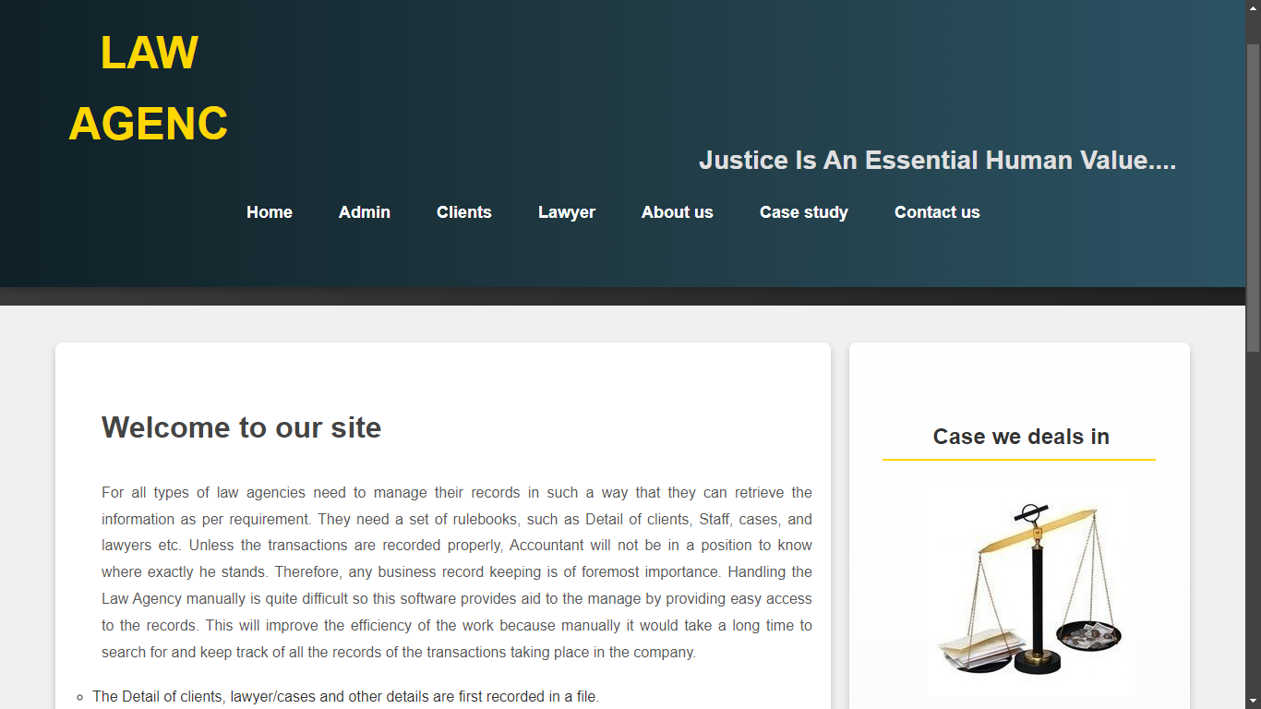­­­­­­­­­**

1. **Admin Page**

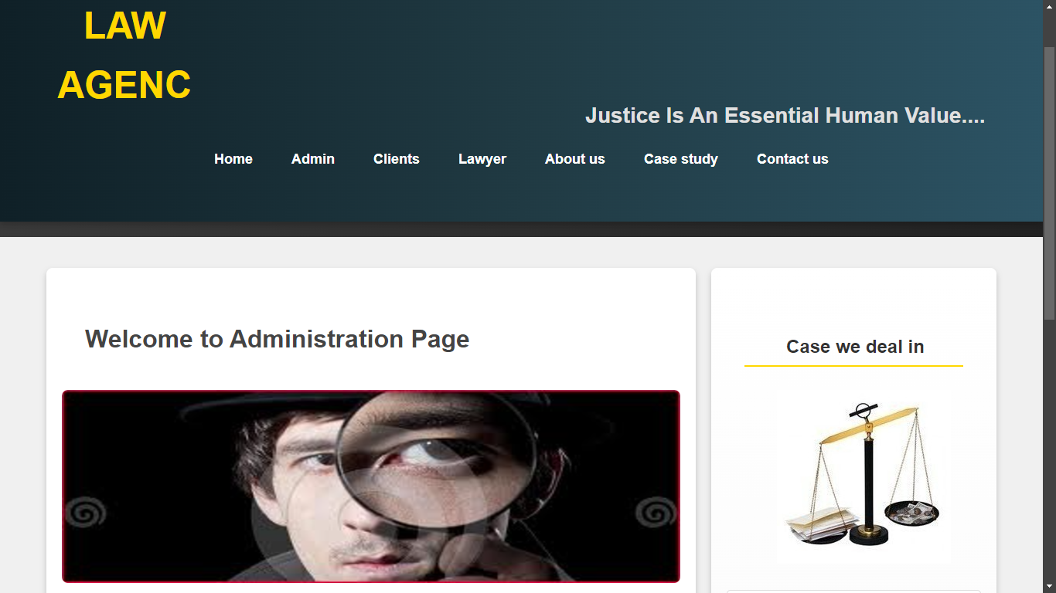

1. **Client Page**

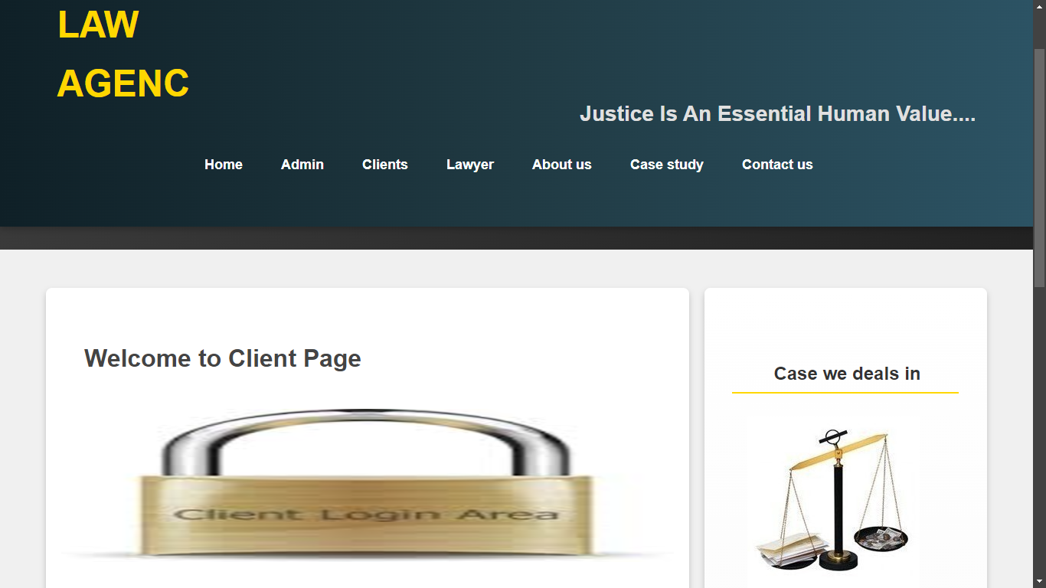

1. **Lawyer Page**

1. **About Us Page**

1. **Contact Page**

1. **Case We Deals In Page**

**Testing Objective**

**Software testing** is an investigation conducted to provide stakeholders with information about the quality of the product or service under test. Software testing also provides an objective, independent view of the software to allow the business to appreciate and understand the risks of software implementation. Test techniques include, but are not limited to, the process of executing a program or application with the intent of finding software bugs.

Not all software defects are caused by coding errors. One common source of expensive defects is caused by requirement gaps, e.g., unrecognized requirements that result in errors of omission by the program designer. A common source of requirements gaps is non-functional requirements such as testability, scalability, maintainability, usability, performance, and security.

**The box approach**

Software testing methods are traditionally divided into white- and black-box testing. These two approaches are used to describe the point of view that a test engineer takes when designing test cases.

**White box testing**

White box testing is when the tester has access to the internal data structures and algorithms including the code that implement these.

Types of white box testing

The following types of white box testing exist:

• API testing (application programming interface) - testing of the application using public and private APIs

• Code coverage - creating tests to satisfy some criteria of code coverage (e.g., the test designer can create tests to cause all statements in the program to be executed at least once)

• Fault injection methods - improving the coverage of a test by introducing faults to test code paths

• Mutation testing methods

• Static testing - White box testing includes all static testing

**Test coverage**

White box testing methods can also be used to evaluate the completeness of a test suite that was created with black box testing methods. This allows the software team to examine parts of a system that are rarely tested and ensures that the most important functional points have been tested

Two common forms of code coverage are:

* Function coverage, which reports on functions executed
* Statement coverage, which reports on the number of lines executed to complete the test

**Black box testing**

Black box testing treats the software as a "black box"—without any knowledge of internal implementation.

**Specification-based testing**: Specification-based testing aims to test the functionality of software according to the applicable requirements. Thus, the tester inputs data into, and only sees the output from, the test object. This level of testing usually requires thorough test cases to be provided to the tester, who then can simply verify that for a given input, the output value (or behavior), either "is" or "is not" the same as the expected value specified in the test case.

**Advantages and disadvantages**:

The black box tester has no "bonds" with the code, and a tester's perception is very simple: a code *must* have bugs. Using the principle, "Ask and you shall receive," black box testers find bugs where programmers do not. On the other hand, black box testing has been said to be "like a walk in a dark labyrinth without a flashlight," because the tester doesn't know how the software being tested was actually constructed. As a result, there are situations when (1) a tester writes many test cases to check something that could have been tested by only one test case, and/or (2) some parts of the back-end are not tested at all.

**Grey box testing**

Grey box testing (American spelling: gray box testing) involves having knowledge of internal data structures and algorithms for purposes of designing the test cases, but testing at the user, or black-box level. Manipulating input data and formatting output do not qualify as grey box, because the input and output are clearly outside of the "black-box" that we are calling the system under test. This distinction is particularly important when conducting integration testing between two modules of code written by two different developers, where only the interfaces are exposed for test. However, modifying a data repository does qualify as grey box, as the user would not normally be able to change the data outside of the system under test. Grey box testing may also include reverse engineering to determine, for instance, boundary values or error messages.

**Software Maintenance**

The integral part of software is the maintenance part which requires accurate maintenance plan to be prepared during software development and should specify how users will request modifications or report problems and the estimation of resources such as cost should be included in the budget and a new decision should address to develop a new system and its quality objectives. The software maintenance which can last for 5–6 years after the development calls for an effective planning which addresses the scope of software maintenance, the tailoring of the post delivery process, the designation of who will provide maintenance, an estimate of the life-cycle costs.

**There are six software maintenance processes as:**

1. The implementation processes contains software preparation and

transition activities, such as the conception and creation of the

maintenance plan, the preparation for handling problems identified

during development, and the follow-up on product configuration management

1. The problem and modification analysis process, which is executed once the application has become the responsibility of the maintenance group. The maintenance programmer must analyze each request, confirm it (by reproducing the situation) and check its validity, investigate it and propose a solution, document the request and the solution proposal, and, finally, obtain all the required authorizations to apply the modifications.
2. The process considering the implementation of the modification itself.
3. The process acceptance of the modification, by confirming the modified work with the individual who submitted the request in order to make sure the modification provided a solution.
4. The migration process (platform migration, for example) is exceptional, and is not part of daily maintenance tasks. If the software must be ported to another platform without any change in functionality, this process will be used and a maintenance project team is likely to be assigned to this task.
5. Finally, the last maintenance process, also an event which does not occur on a daily basis, is the retirement of a piece of software.
6. There are a number of processes, activities and practices that are unique to maintainers, for example:

**Conclusion**

This project is designed to meet the requirements of a good **Law Agency**. It has been developed in php, keeping in mind the specifications of the system. All the expectations of the Law Agency have been lived up to and the management is pretty happy about the working of the system.

All the problems that were listed in the problem definition have been corrected and certain extra features have been added to make sure changes can be incorporated to the system at later stages. For designing the Law Agency we have used simple data flow diagrams.

**References**

BONELL, Michael Joachim - The 1983 Geneva Convention on Agency in the International Sale of Goods, in: The American Journal of Comparative Law, Vol. 32, No. 4 (Autumn, 1984), pp. 717-749

 BONELL, Michael Joachim – Agency, in: Hartkamp A.S. / Hesselink M.W. / Hondius E.H. / Mak C. / du Perron E. (eds.), Towards a European Civil Code, 4th. ed., Kluwer Law International 2011, 515-536

 EVANS, M. Explanatory Report on the Convention on Agency in the International Sale of Goods, in: Revue de droit uniforme / Uniform Law Review 1984, I, 73-159 (odd pages)

 EVANS, M. Rapport explicatif sur la Convention sur la représentation en matière de vente internationale de marchandises, in: Revue de droit uniforme / Uniform Law Review 1984, I, 72-158 (pages paires)

 FERNÁNDEZ GREGORACI, B - Representación indirecta y *Undisclosed agency*: su convergencia (la *Convention on Agency in the International Sale of Goods y los Principles of European Contract Law*), in: Anuario de derecho civil, 55 (2002), 1717-1749

 GRÖNFORS, K. - Unification of agency as a legislative challenge, in: Uniform Law Studies in memory of Malcolm Evans, Uniform Law Review, 1998-2/3, 467-474